Guideline install ESP8266 SDK on windows

1. Link refer

* <https://github.com/espressif/ESP8266_RTOS_SDK>
* <https://docs.espressif.com/projects/esp8266-rtos-sdk/en/latest/get-started/windows-setup.html#introduction>
* https://docs.espressif.com/projects/esp8266-rtos-sdk/en/latest/get-started/index.html#get-started-get-esp-idf

1. Download

* MSYS

<https://dl.espressif.com/dl/esp32_win32_msys2_environment_and_toolchain-20181001.zip>

* Toolchain

<https://dl.espressif.com/dl/xtensa-lx106-elf-gcc8_4_0-esp-2020r3-win32.zip>

1. Setup path environment

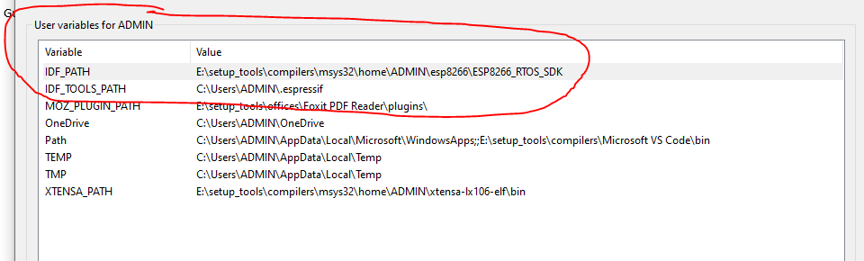

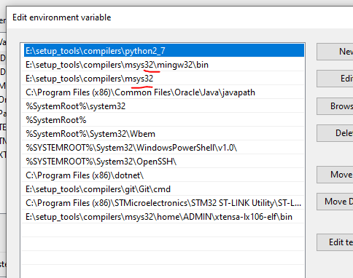

1. Git clone ESP8266_RTOS_SDK về folder cần dùng.
2. Chạy lệnh: python -m pip install --user -r $IDF_PATH/requirements.txt

* Để install các package cần thiết.

1. Mở file 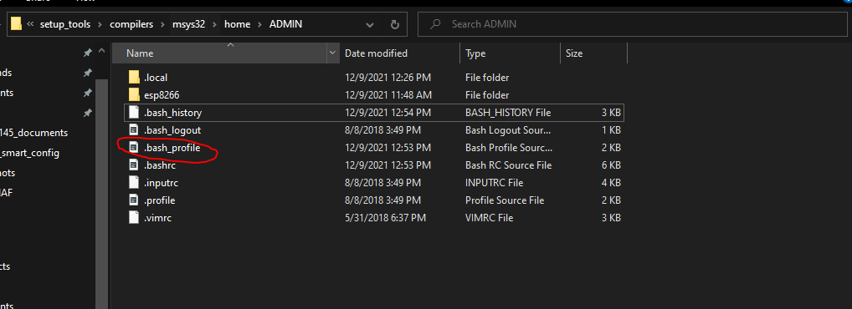

* Add dòng lệnh:

export PATH=$PATH:/opt/xtensa-lx106-elf/bin

export IDF_PATH="E:\setup_tools\compilers\msys32\home\ADMIN\esp8266\ESP8266_RTOS_SDK"

1. Mở example lên và chạy thử

